January 2010
Issue 10
Safety Matters

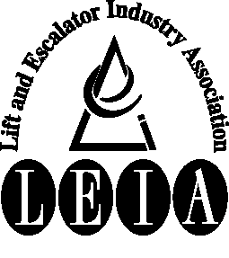
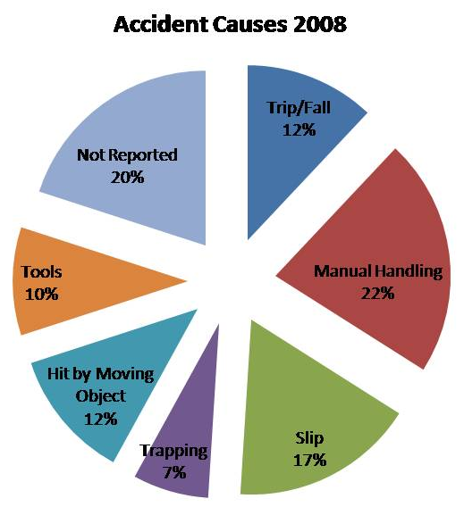
Articles:

• Industry Accidents

• Lift Car Top Access

• Opening Landing Doors

• Handling and Disposal of Batteries

Tel: 020 7935 3013
Fax: 020 7935 3321
Email: enquiries@leia.co.uk
Welcome to the January 2010 edition of Safety Matters.
Through this newsletter our aim is to inform you of health and safety issues that may have an impact on the Lift & Escalator industry. Safety Matters is also available for download from the LEIA member’s website. www.leia.co.uk

Introduction

Industry Accidents

Slips were another high cause of accident in the industry. Two major accidents were reported, one where an engineer slipped on a wet stairway and another on an uneven surface in the machine room.

There are some simple steps that can be undertaken to reduce the risk of slipping which include:-

- Checking the route you are intending to walk along.
- Check the condition of the steps or ladder you are to use.
- The cleanliness of your footwear i.e. have you got mud on the sole?
- Use handrail whenever possible.

The list is just an example of some of the checks that can be undertaken.

Tools were also highlighted as the cause of a number of accidents causing injury to the user. The following is a list of some of the circumstance relating to this type of accident:-
- Hand slipped whilst using tool.
- Knife injury whilst cutting.
- Tool slipping.
- Drilling operations.
Take care and check your tools are in good condition before use. Always ensure you are using them in the way you were instructed, and that it is the correct tool for the job. Improvising by using the wrong tools or equipment can cause an accident. The use of gloves can also reduce the injury.
In the most recent set of accident statistics issued by LEIA it was identified that there had been a decrease in the number accidents to industry field employees. However this probably reflects that there were fewer people employed in the industry that year so the accident rate was about the same.

Manual Handling was the biggest cause of accident reported. Accidents reported included one where an unstable load fell whilst being carried which resulted in a fracture to the shoulder of an engineer. Other reports included engineers undertaking manual lifting and sustaining injury to their back due to poor techniques or posture. Interestingly there were no accidents reported that resulted from a person trying to lift excessively heavy items.

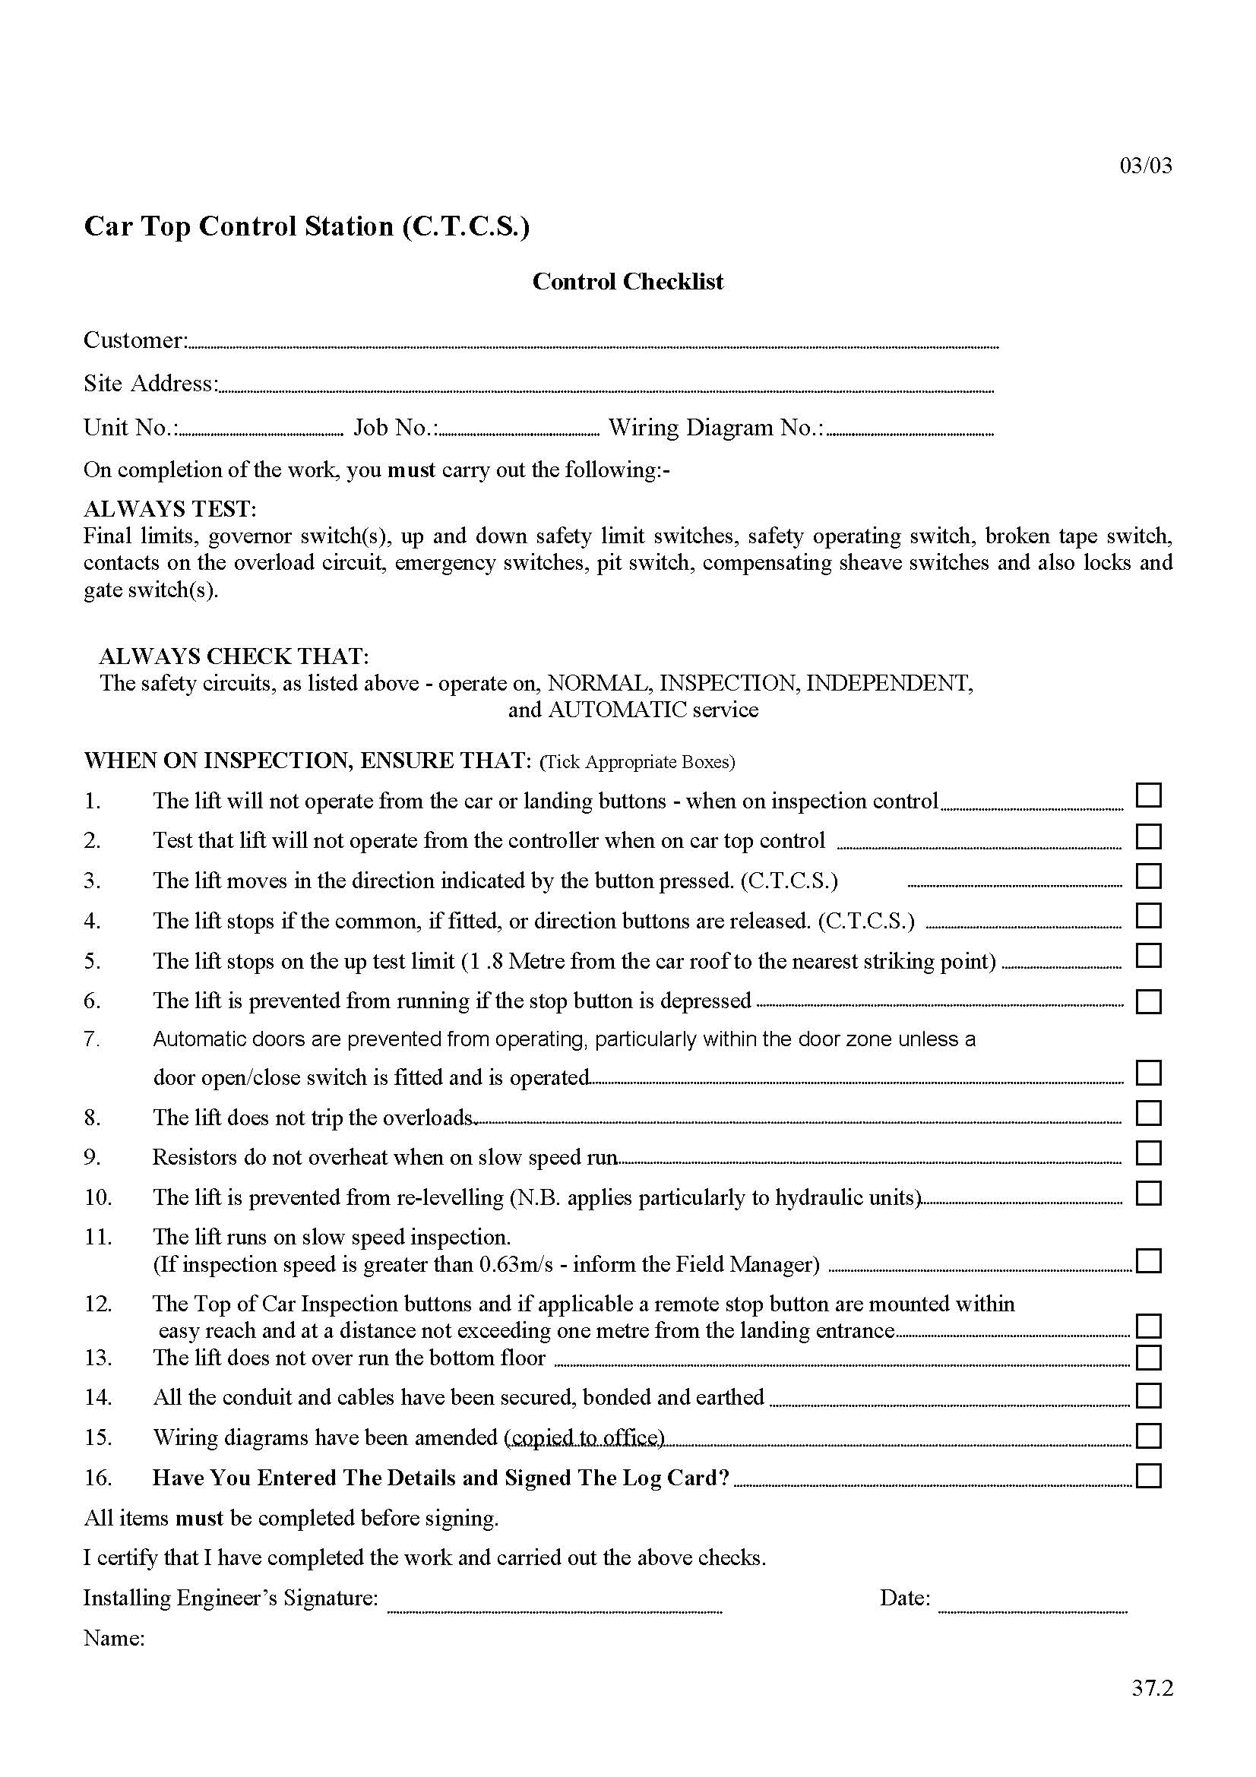
Car Top Access
Following a number of accidents of which some were fatal LEIA produced guidance to the suitability of different styles and types of Car Top Control Station. Companies have adapted the guidance into their own procedures regarding the checks to be made prior to accessing a car top and ensuring the controls work correctly. You should always follow your own company procedure which is likely to include:-

- Checks on stop the switch – to ensure it is operational
- Checks on the changeover switch – to ensure when on test the lift will not operate under normal control
- Checks on the Up / Down and Common pushes - to ensure correct operation.

Where a new Car Top Control Station has been fitted to an old lift LEIA has produced a check list that can be followed before the unit is returned to service, again many companies will have their own procedure.

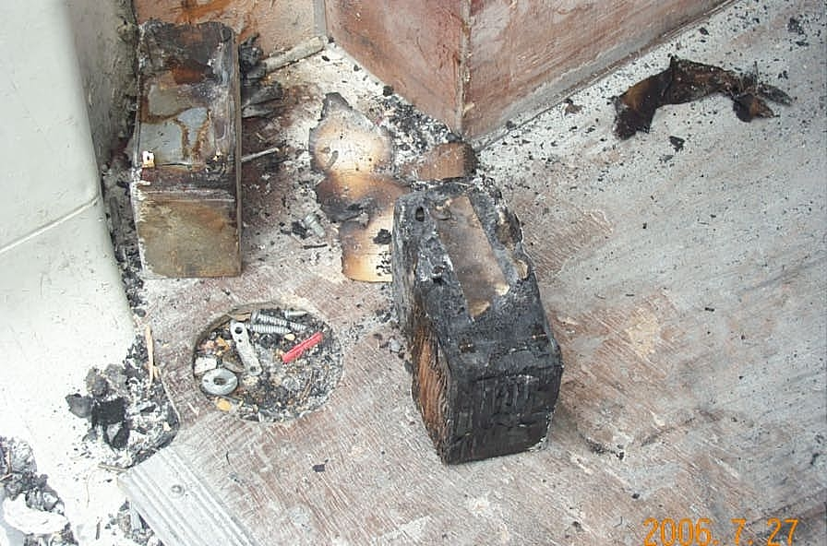
Rechargeable batteries are now extensively used in a number of applications including stairlifts, emergency lights, standby power supply tools etc.

New batteries should be transported in their packaging to prevent a short and old batteries should have their terminals insulated using insulating tape or similar before they are removed for disposal.

Care needs to be taken when batteries are removed from products as the battery may still be capable of delivering a high current or if the terminals are accidently shorted out then there is considerable heat generated which can cause a fire.

Used lead-acid batteries are considered as hazardous waste and special arrangements are required for their disposal and/or recycling. Used batteries must be disposed of correctly.

If in any doubt on how to dispose of batteries, ask!

Handling and Disposal of Batteries

Opening Landing Doors
Work at Height is covered by a LEIA Safety Information sheet available from the Association or downloadable from their website. Wherever work at height is undertaken there must be steps taken to prevent people falling.

It is worth remembering that standard landing entrance barriers are designed to protect others in the building, they are not usually intended to prevent the lift engineer from falling.

It is easy to forget that during service work opening a landing door can place the person who opened the door at height, with a potential for falling.

Ideally if the lift car is in the correct position the top of the car will prevent falls but where this is not the case a procedure should be in place to deal with this situation. One example would be to limit how far a landing door can be opened so that the position of the lift car can be established and moved accordingly.

Suitable ladders are required when accessing the pit from the lower level to avoid overstretching and falling.

In some situations special arrangements may be required to prevent falls. If in doubt consult your company procedure or speak to your supervisor for advice.
Burnt battery as a result of being shorted out

